BLOOD BANK MGT

USE CASE DIAGRAM

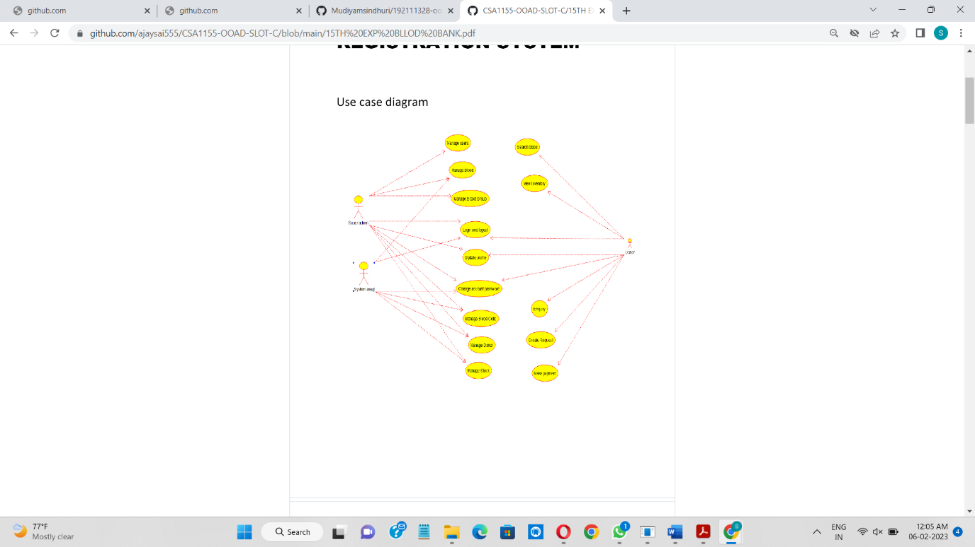

CLASS DIAGRAM

